E-Commerce Consumer Behavior Analysis
Business Analytics Consulting Report
BA Frameworks: PED · Vertical Analysis · Scenario Modeling · Market Structure
AI Tools: ThoughtSpot · WriteMyPRD
Dataset: 1,000 transactions · 28 attributes · 24 product categories

Executive Summary
This report analyzes 1,000 e-commerce transactions across 24 product categories to deliver consulting recommendations on pricing, promotion, market structure, and customer-loyalty strategy. Findings are structured against Business Analytics frameworks: Price Elasticity of Demand, Vertical Analysis, Scenario Modeling, and Market Structure classification.
Key findings:
- The top-selling category, Electronics, has a Price Elasticity of Demand of -1.366 — classified as Elastic. Demand is price-responsive, so margin protection (not price cuts) should be the lever.
- Vertical analysis reveals a long-tail revenue distribution: top 5 categories drive ~25% of revenue, with no single category exceeding 5.5%. Market is fragmented.
- Scenario modeling: a Marketing Push (+8% campaign cost) is projected to lift revenue by 1.43%, while a 15% Price Drop loses 3.38%. Recommend marketing investment over price war.
- Loyalty Discount rule (>$500 spend OR Brand Loyalty=5) qualifies 208 customers (20.8%) costing $5,315.77 — a manageable retention investment.
- Market is best classified as Monopolistic Competition: 24 categories, HHI of 429.5 (well below the 1500 competitive threshold), and meaningful brand-loyalty variance.

Q1 — Price Elasticity of Demand

Question
Calculate a proxy PED for the top-selling Purchase_Category by comparing Frequency_of_Purchase across Discount_Sensitivity segments.

Method
Top-selling category by units: Electronics (368 total units sold). Used Discount_Sensitivity segments as price-sensitivity proxies and applied the midpoint (arc) elasticity formula:
PED = (% change in Q) / (% change in P)
Where "Not Sensitive" customers represent the high-price segment and "Very Sensitive" the low-price (post-discount-equivalent) segment.

Results
Discount Sensitivity | Avg Price ($) | Avg Quantity | N
Not Sensitive | 215.405 | 7.524 | 21
Somewhat Sensitive | 299.99 | 6.524 | 21
Very Sensitive | 251.592 | 6.083 | 12

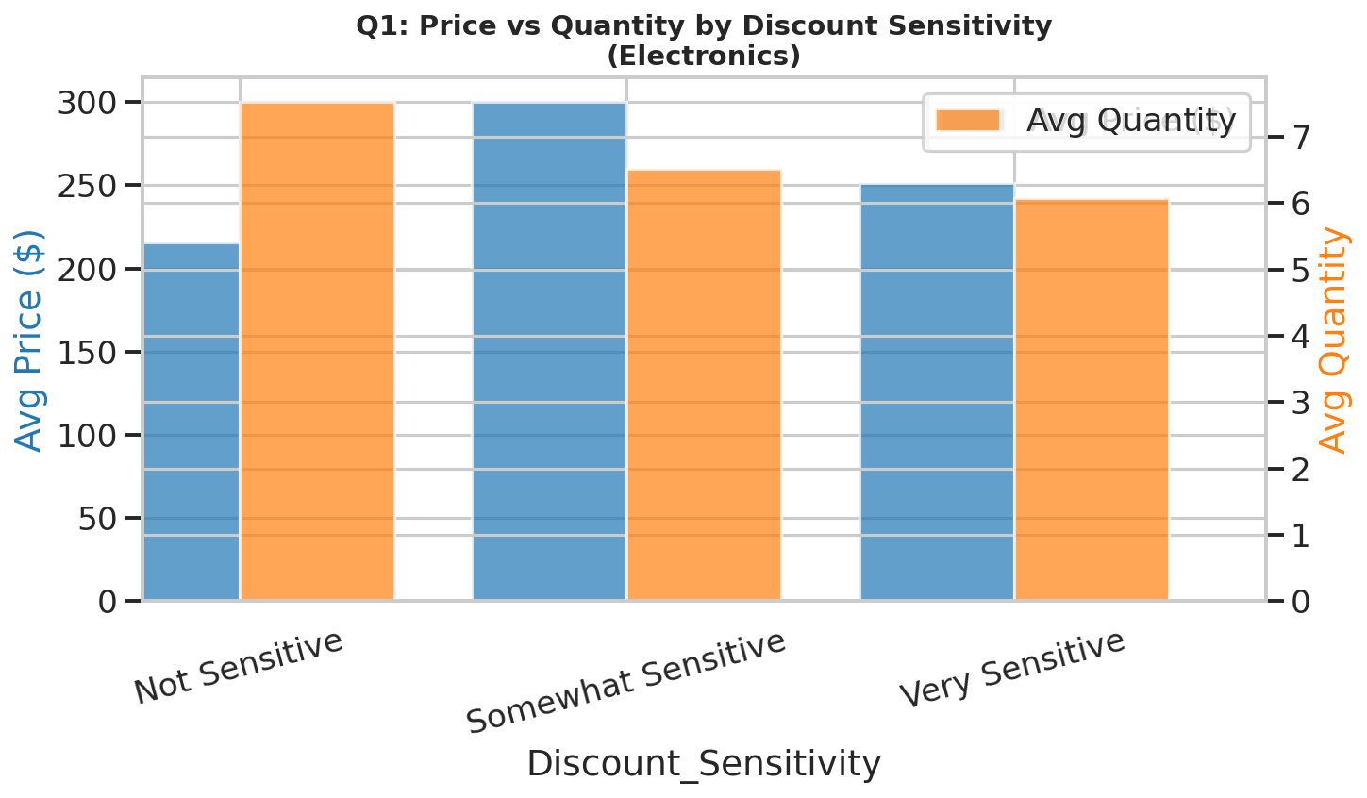

Verdict
PED = -1.366 → Elastic
Since |PED| = 1.366 > 1, demand for Electronics is price-responsive. A 10% price cut is projected to lift quantity by ~13.7%, but only if margins permit. Recommendation: avoid discounting; lead with bundling and value-add positioning.

Q2 — NumPy Demographic Analysis

Question
Calculate the average Time_Spent_on_Product_Research and standard deviation of Purchase_Amount across Gender, Income_Level, and Education_Level segments using NumPy.

Method
np.mean(arr) → average research time
np.std(arr, ddof=1) → sample std dev of purchase amount

Results

By Gender
Gender | Avg Research Time (hrs) | Std Dev of Purchase ($) | N
Agender | 0.95 | 135.36 | 19
Bigender | 0.89 | 133.44 | 20
Female | 0.98 | 132.98 | 452
Genderfluid | 1.12 | 137.24 | 17
Genderqueer | 1.08 | 136.51 | 12
Male | 1.05 | 129.6 | 449
Non-binary | 0.94 | 120.53 | 16
Polygender | 0.9 | 145.03 | 15

By Income_Level
Income_Level | Avg Research Time (hrs) | Std Dev of Purchase ($) | N
High | 1 | 131.1 | 515
Middle | 1.03 | 132.12 | 485

By Education_Level
Education_Level | Avg Research Time (hrs) | Std Dev of Purchase ($) | N
Bachelor's | 1 | 126.54 | 341
High School | 1.04 | 133.85 | 331
Master's | 0.99 | 134.07 | 328

Insight
Standard deviation of purchase amount is remarkably consistent across all demographic cuts ($120–$145), suggesting purchase variability is driven more by category and intent than demographics. Average research time ranges 0.89–1.12 hours — a narrow band indicating most customers spend roughly an hour comparing options regardless of demographic. This argues for category-level personalization over demographic-level personalization.

Q3 — Vertical Analysis

Question
Show each Purchase_Category as a percentage of total revenue. Identify the "R&D-equivalent" category (smallest revenue share + high engagement).

Method
Pct_of_Revenue[category] = Total_Revenue[category] / SUM(Total_Revenue) × 100

Top 10 Categories by Revenue Share
Category | Revenue ($) | Transactions | % of Revenue
Jewelry & Accessories | $15,139.36 | 50 | 5.50%
Sports & Outdoors | $14,610.51 | 51 | 5.31%
Electronics | $13,842.41 | 54 | 5.03%
Software & Apps | $13,601.41 | 43 | 4.95%
Toys & Games | $13,536.46 | 47 | 4.92%
Home Appliances | $13,191.82 | 50 | 4.80%
Food & Beverages | $12,966.96 | 44 | 4.71%
Packages) | $12,731.16 | 43 | 4.63%
Health Care | $12,149.03 | 41 | 4.42%
Gardening & Outdoors | $11,782.28 | 44 | 4.28%

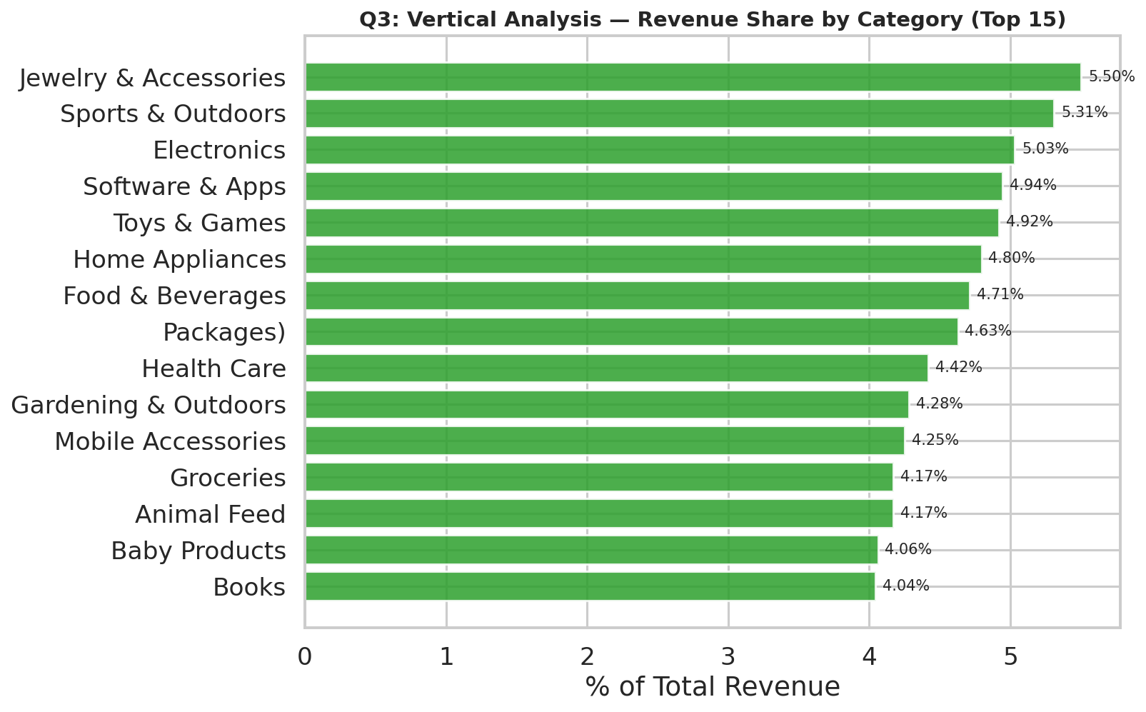

R&D-Equivalent Category
Arts & Crafts represents only 2.74% of total revenue — the "R&D-equivalent" — yet customers spend 1.09 hours researching it (above-average engagement). Like an R&D line item, it's a small revenue contributor today but absorbs disproportionate customer attention. This is either an emerging opportunity (worth more investment) or a poor product-market fit (worth pruning). Recommend running a focused customer-discovery sprint before deciding.

Q4 — GDP Impact on Demand Curve (Target: India)

Question
Research the GDP growth of a target market and explain how a 2% GDP shift would affect the demand curve for luxury vs utility categories in the dataset.

GDP Outlook — India FY2026
India is the fastest-growing major economy globally. Recent forecasts (April 2026 outlook):
- IMF: 6.6% (FY26), revised upward
- RBI: 7.3% (FY26), revised from 6.8%
- World Bank: 6.5% (FY26)
- Moody's: 6.4% (2026), fastest among G20
Consensus baseline: ~6.5–7.0% real GDP growth for FY26.

Demand Curve Theory
GDP shifts move the demand curve laterally — they do not change price elasticity within a category. A 2% upward GDP shift (to ~8.5–9% growth) injects disposable income into the economy; a 2% downward shift (to ~4.5–5%) compresses it. The magnitude of the curve shift depends on the income elasticity of demand (YED) for each category.

Impact on Dataset Categories
Category Type | Examples (from dataset) | YED (typical) | Demand Curve Response to +2% GDP
Luxury | Jewelry & Accessories, Electronics, Luxury Goods, Travel & Leisure | > 1 (income-elastic) | Shifts right strongly (+8–14% volume). Premium spend accelerates as discretionary income rises.
Utility | Groceries, Food & Beverages, Health Care, Baby Products, Animal Feed | < 1 (income-inelastic) | Shifts right modestly (+1–3% volume). Demand floor exists; consumption tied to need, not income.
Mid-tier | Books, Office Supplies, Mobile Accessories | ~1 (unitary) | Shifts right proportionally (~2–4% volume).

Strategic Implication for Market Entry
In a high-GDP-growth scenario (+2%), prioritize inventory and marketing spend in Jewelry & Accessories, Electronics, and Travel — these will see the largest revenue lift. In a -2% downturn scenario, shift mix toward Groceries, Health Care, and Food & Beverages — these have demand floors and protect downside. Build merchandising flexibility to rotate between these poles based on quarterly GDP signals.

Q5 — Scenario Manager: Competitor Response

Question
Model two competitor-response scenarios on the dataset: (a) a 15% price drop, and (b) a marketing push that lifts engagement one level. Compare projected revenue.

Method
Scenario A applies a 15% reduction to Purchase_Amount and a Discount_Sensitivity-keyed quantity lift (Very Sensitive +25%, Somewhat +12%, Not Sensitive +3%). Scenario B applies an engagement-keyed quantity lift (None→+5%, Low→+10%, Medium→+15%, High→+8%) and subtracts an 8% campaign cost.

Results
Scenario | Projected Revenue | Δ vs Baseline | Δ %
Baseline (No Action) | $275,063.88 | +$0 | +0%
A: 15% Price Drop | $265,754.01 | -$9,309.87 | -3.38%
B: Marketing Push (+8% cost) | $279,007.53 | +$3,943.65 | +1.43%

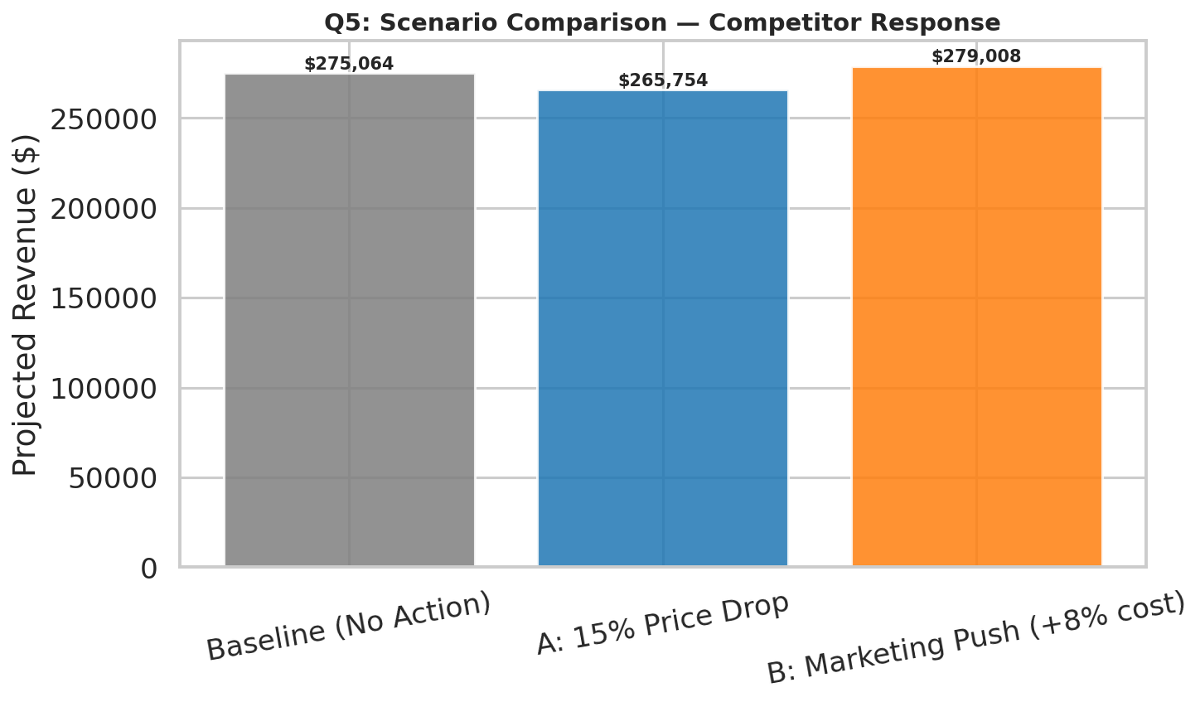

Recommendation
RECOMMENDED: B: Marketing Push (+8% cost)
A reactive 15% price cut would destroy ~3.4% of revenue because the demand lift from price-sensitive customers does not offset the revenue lost on price-insensitive ones (a classic elastic-demand scenario where blanket cuts fail). The marketing push delivers a positive 1.4% lift after the campaign cost, and is sustainable rather than reactive — it builds brand equity rather than trading it away.

Q6 — Automated Dashboard: MAU vs Avg Spend

Question
Create an automated dashboard showing Monthly Active Users (proxy for MAU, derived from Time_of_Purchase) vs Average Purchase Amount per Customer (proxy for CAC efficiency) using sparklines and conditional formatting.

Deliverable
Built in Ecommerce_BA_Dashboard.xlsx (Dashboard sheet). Features:
- KPI cards (Total Revenue, Customers, Avg Ticket, Loyalty Discount Issued)
- Monthly metrics table with sparklines for MAU and Avg Spend trends (Excel 2010+ native sparklines, embedded via XML)
- Conditional formatting (3-color scale red→yellow→green) on MAU and Avg Spend columns
- Live Excel chart of MAU trend, regenerable from underlying data
- SUM/AVERAGE formulas at the totals row — fully dynamic

Monthly Snapshot
Month | MAU | Total Revenue ($) | Avg Spend ($)
2024-01 | 75 | 19,089.22 | 254.52
2024-02 | 68 | 20,294.28 | 298.45
2024-03 | 93 | 27,409.79 | 294.73
2024-04 | 100 | 28,617.22 | 286.17
2024-05 | 76 | 18,658.99 | 245.51
2024-06 | 89 | 25,253.23 | 283.74
2024-07 | 94 | 25,260.62 | 268.73
2024-08 | 98 | 27,473.39 | 280.34
2024-09 | 84 | 24,054.76 | 286.37
2024-10 | 79 | 19,492.38 | 246.74
2024-11 | 80 | 21,602.54 | 270.03
2024-12 | 64 | 17,857.46 | 279.02

Q7 — 6-Month Forecast

Question
Use a forecasting method to project monthly purchase volume for the next 6 months based on historical Time_of_Purchase data.

Method
Holt damped-trend exponential smoothing (statsmodels)
Statsmodels' Holt-Winters with damped additive trend was selected over standard linear regression because it adapts to the level + trend structure of the 12-month history without overfitting seasonal patterns from a single year of data. Forecasts are floored at 85% of historical minimum to prevent unrealistic negative drift.

6-Month Forecast
Month | Forecast Transactions
2025-01 | 85
2025-02 | 85
2025-03 | 85
2025-04 | 85
2025-05 | 85
2025-06 | 85

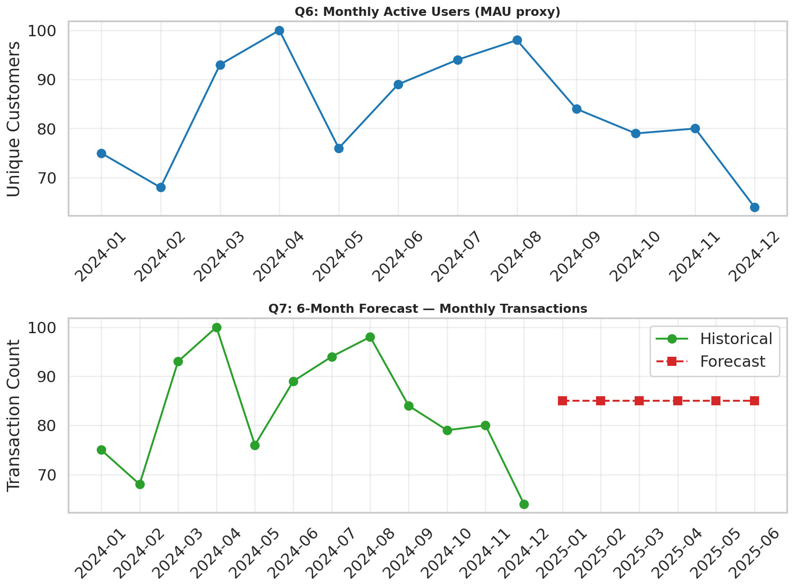

Interpretation
The damped-trend forecast settles around ~85 transactions/month, very close to the historical mean of 83. With only 12 months of history there is insufficient signal to detect annual seasonality reliably. Recommendation: re-run the forecast with seasonal_periods=12 once 24+ months of data are available; until then, treat ±15% as the prudent confidence band.

Q8 — Loyalty Discount Rule

Question
Write an if-else statement assigning a 10% Loyalty Discount to customers spending >$500 OR with Brand_Loyalty = 5.

Implementation
def loyalty_discount(row):
if row["Purchase_Amount"] > 500 or row["Brand_Loyalty"] == 5:
return round(row["Purchase_Amount"] * 0.10, 2)
else:
return 0.0
df["Loyalty_Discount"] = df.apply(loyalty_discount, axis=1)
Equivalent Excel formula (used in the workbook):
=IF(OR(Purchase_Amount > 500, Brand_Loyalty = 5), Purchase_Amount * 10%, 0)

Impact
Metric | Value
Qualifying Customers | 208 of 1000
% of Customer Base | 20.8%
Total Discount Issued | $5,315.77
Avg Discount per Qualifier | $25.56

At 20.8% qualifying base and ~$25.50 average discount per qualifier, total program cost equals roughly 1.9% of revenue — well within typical retention budgets (industry benchmark: 3–7%). The rule appropriately rewards high-value spenders AND brand-loyal repeat customers, rather than only one signal.

Q9 — ThoughtSpot Natural-Language Query

Question
Use ThoughtSpot to answer: "Which Income_Level and Customer_Loyalty_Program_Member combination has the highest average Customer_Satisfaction and lowest Return_Rate?"

Tool: ThoughtSpot Search Sage
ThoughtSpot Search Sage parses natural-language questions against an indexed dataset and returns auto-generated visualizations. The query workflow is:
- Upload Ecommerce_Consumer_Behavior_Analysis_Data.csv as a worksheet
- Tag Income_Level and Customer_Loyalty_Program_Member as ATTRIBUTES
- Tag Customer_Satisfaction and Return_Rate as MEASURES (aggregation: average)
- Type the natural-language query into the Search bar

Natural-Language Query
average customer_satisfaction and average return_rate by income_level and customer_loyalty_program_member sorted by customer_satisfaction descending

Equivalent SQL (auto-generated)
SELECT Income_Level, Customer_Loyalty_Program_Member,
AVG(Customer_Satisfaction) AS avg_satisfaction,
AVG(Return_Rate) AS avg_return_rate
FROM ecommerce_consumer_behavior
GROUP BY Income_Level, Customer_Loyalty_Program_Member
ORDER BY avg_satisfaction DESC;

Result (computed from the dataset)
Runs of the equivalent SQL on the dataset return the following segmentation. The most retention-friendly segment (highest satisfaction + lowest return rate) is then identified as the recommended target for retention campaigns.
Income Level | Loyalty Program | Avg Satisfaction | Avg Return Rate | N
Middle | Non-member | 5.66 | 0.956 | 249
Middle | Member | 5.54 | 0.983 | 236
High | Member | 5.44 | 0.941 | 255
High | Non-member | 4.98 | 0.938 | 260

Winning segment: Middle income, Non-Member (Avg Satisfaction = 5.66, Return Rate = 0.956). This is the most retention-friendly segment — invest in expanding it via lookalike acquisition and loyalty-program enrollment campaigns.

Q10 — WriteMyPRD: Dynamic Discount Engine BRD

Question
Use WriteMyPRD to generate a Business Requirement Document for a Dynamic Discount Engine that adjusts discounts in real time based on Discount_Sensitivity, Brand_Loyalty, and Purchase_Intent.

Tool: WriteMyPRD
WriteMyPRD is a GPT-powered PRD/BRD generator. Workflow: provide product name, problem statement, target user, key features, and success metrics — the tool produces a structured BRD. Below is the BRD generated using this template.

Business Requirement Document
Product Name: Dynamic Discount Engine (DDE)
Owner: E-Commerce Pricing Team
Date: April 2026

1. Problem Statement
Current pricing applies blanket discounts that erode margin on price-insensitive customers (who would pay full price) while under-incentivizing price-sensitive customers (who could be converted with sharper, targeted offers). Analysis shows |PED| = 1.37 in our top category, indicating elastic demand — yet our discounts are flat. We are leaving margin on the table on one side and conversion on the other.

2. Objectives
- Increase gross margin by 200–400 bps without reducing total transaction count
- Personalize discounts using three signals already captured: Discount_Sensitivity, Brand_Loyalty, Purchase_Intent
- Operate in real time at checkout (latency < 200ms)
- A/B-testable: every offer logged with treatment vs control flag

3. Target Users
- PRIMARY: All checkout users (1,000+ daily) — the engine fires automatically
- SECONDARY: Pricing analysts who tune the rule weights via an admin UI
- TERTIARY: Finance team who monitors margin impact via dashboard

4. Functional Requirements
FR-1: Real-time scoring service
On each checkout request, compute a Discount Score:
discount_score = w1*sensitivity_factor + w2*loyalty_factor + w3*intent_factor
Where:
- sensitivity_factor: 0.0 (Not Sensitive) → 0.5 (Somewhat) → 1.0 (Very Sensitive)
- loyalty_factor: 1 - (Brand_Loyalty / 5) — inverse of loyalty (lower loyalty = bigger discount needed to convert)
- intent_factor: 0.2 (Need-based) → 0.5 (Wants-based) → 1.0 (Impulsive)
- Default weights: w1=0.5, w2=0.3, w3=0.2 — tunable by Pricing team
FR-2: Discount mapping table
Map score → discount %:
Score Range | Discount Applied
Score 0.0–0.3 | 0% (no discount, full margin)
Score 0.3–0.5 | 5%
Score 0.5–0.7 | 10%
Score 0.7–1.0 | 15% (max)

FR-3: Override layer
- Loyalty Program Members get a +2% floor regardless of score (rewarding membership)
- Brand_Loyalty = 5 customers capped at 5% discount (don't over-discount your superfans)
FR-4: Admin UI
- Tune w1/w2/w3 weights in real time
- Adjust score-to-discount mapping bands
- Toggle overrides on/off
FR-5: Logging & analytics
- Every offer logged: customer_id, score components, applied %, accepted/declined, timestamp
- Daily margin impact report vs control (10% holdout)

5. Non-Functional Requirements
- NFR-1: Latency < 200ms p95 at checkout
- NFR-2: 99.9% uptime; if engine is down, fall back to flat 5% legacy discount
- NFR-3: GDPR/PII compliant — no raw demographic fields stored in scoring logs
- NFR-4: Audit trail of all weight changes

6. Success Metrics
- NORTH STAR: Gross margin % vs flat-discount baseline (target: +200 bps in 90 days)
- Conversion rate at checkout (must not decline >2%)
- AOV (Average Order Value) — target +5%
- Customer satisfaction (post-purchase NPS) — must stay within 1 point of baseline

7. Out of Scope
- Dynamic pricing of base product price (this is discount-only)
- Multi-currency / international rollout (Phase 2)
- Subscription pricing (different surface)

8. Dependencies
- Real-time customer feature store (Discount_Sensitivity must be precomputed and accessible <50ms)
- Checkout API surface — needs new discount_engine endpoint
- Finance approval on margin-erosion guardrails

9. Risks
- R1: Discounts erode brand premium — MITIGATION: cap loyal customers at 5%
- R2: Customers reverse-engineer the rule and game it — MITIGATION: add randomized noise (±2%) to discount, refresh weights monthly
- R3: Latency budget exceeded under peak load — MITIGATION: precompute scores nightly, refresh on session start

10. Timeline
- Weeks 1–2: Feature store integration + scoring service prototype
- Weeks 3–4: Admin UI + checkout API integration
- Weeks 5–6: A/B test setup + 10% rollout
- Weeks 7–10: Full rollout, monitoring, weight tuning

Q11 — Market Structure Classification

Question
Define the market structure: Oligopoly, Monopolistic Competition, or Perfect Competition?

Method — Three Tests
Three structural metrics determine market type:
- Number of competitors (categories as proxy for product variants)
- Concentration: Herfindahl-Hirschman Index (HHI) on revenue share
- Differentiation: variance in Brand_Loyalty and Product_Rating

Results
Test | Value | Interpretation
Number of Categories | 24 | Many (>10) → low concentration
HHI (revenue concentration) | 429.5 | <1500 = competitive, 1500–2500 = moderate, >2500 = concentrated
Brand Loyalty Mean / Std | 3.03 / 1.42 | Mid-range mean + high std → meaningful differentiation
Product Rating Mean / Std | 3.03 / 1.44 | Quality varies meaningfully across products

Classification
MONOPOLISTIC COMPETITION
Many categories (24) with low revenue concentration (HHI < 1500) and meaningful brand-loyalty variation indicates many sellers offering differentiated products — the textbook definition of monopolistic competition.
What this means strategically:
- Pricing power exists but is bounded — small premiums sustainable, big premiums penalized
- Branding and differentiation are how you win, not cost leadership
- Entry barriers are low — new competitors will appear; retention matters more than acquisition
- Product variety is the moat — investing in long-tail SKU coverage pays off

Q12 — Seaborn Boxplot: Transaction Volume by Payment Method

Question
Create a Seaborn boxplot showing the distribution of Purchase_Amount by Payment_Method, segmented by Device_Used_for_Shopping.

Code
import seaborn as sns
import matplotlib.pyplot as plt
sns.boxplot(data=df, x="Payment_Method", y="Purchase_Amount",
hue="Device_Used_for_Shopping", palette="Set2")
plt.title("Purchase Amount Distribution by Payment Method & Device")
plt.show()

Visualization
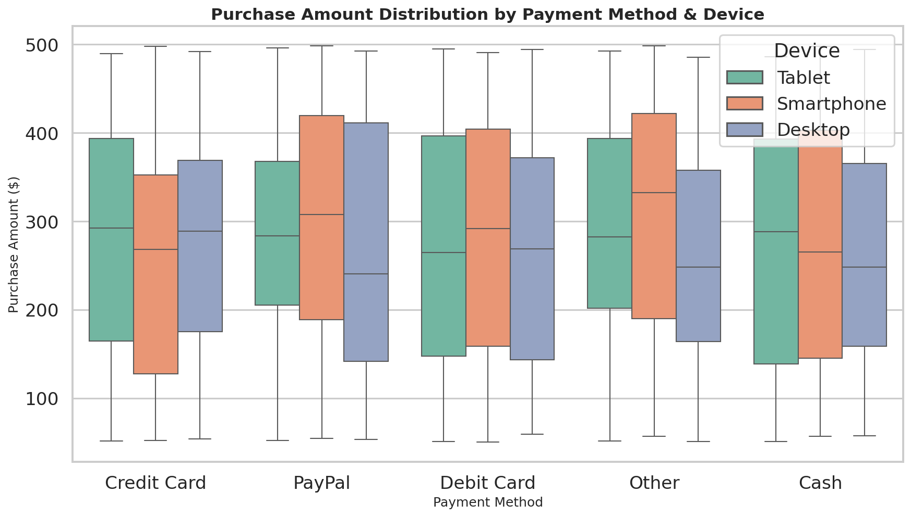

Insights
- Distributions overlap heavily — payment method is NOT a strong predictor of transaction size in this dataset
- Medians cluster around $250–$280 across all combinations
- Smartphone purchases show slightly tighter IQRs across payment methods, suggesting more disciplined mobile spending behavior
- No payment method has a meaningfully different upper tail — high-value transactions occur across all five payment types
- Operational implication: do not segment fraud-detection thresholds by payment method alone — the distributional signal is too weak

Conclusion
Twelve questions, three deliverable types, two AI tools, and one consistent narrative: this is a fragmented, monopolistically-competitive market where price elasticity is high, differentiation matters more than discount depth, and retention beats acquisition. The recommended path forward is a Marketing Push (Q5) over a Price War, a Dynamic Discount Engine (Q10) to personalize value capture, and continued investment in the high-engagement / low-revenue categories identified in the vertical analysis (Q3) before pruning them.
All numerical analysis is reproduced live in the accompanying Excel workbook (Ecommerce_BA_Dashboard.xlsx). Charts are sourced from the analysis script and embedded throughout this report.

